Use Case Diagrams
The actors who have been identified in the system are as follows:
- Investigating officer
- Administrator
- Writer

Investigating officer: He is the actor who can practically work upon the existing data in the police station only for view purpose.

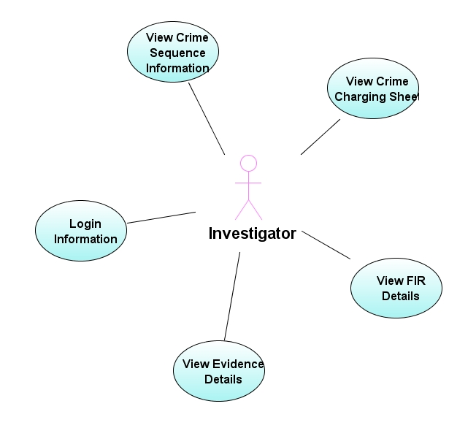
Administrator: He is the actor who has the full-length potentiality and privilege to carry out transactions upon the system. He is authorized to maintain consistency within the information.

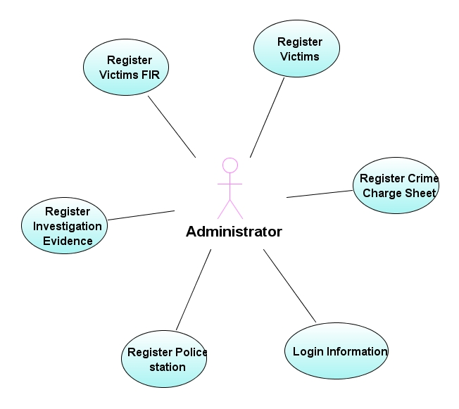

Writer: He is the actor who can enter all the details of the crime or evidence. Once entered cannot be edited. Only the administrator can edit or delete the record from the database.
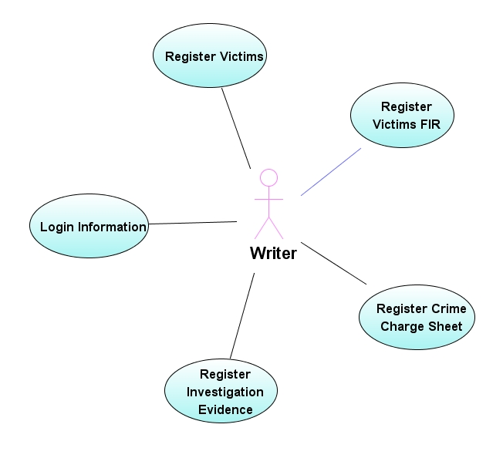

Use case Description:

Use case name | Login Information
Participating actors | Administrator, Investigator, Writer
Flow of events | Provides username and password
Entry Condition | Users must know the username and password
Exit condition | User successfully logged into the system
Quality Requirements | Should provide proper error messages while login into the system.

Use case name | Register Victims
Participating actors | Administrator, Writer
Flow of events | User will enter the Victims information
Entry Condition | User should know the details of the victim
Exit condition | Victim details are successfully inserted into the system.
Quality Requirements | Display proper error messages while insertion.

Use case name | Register Victims FIR
Participating actors | Administrator, Writer
Flow of events | User will register the FIR
Entry Condition | User should know the details of the FIR
Exit condition | FIR details are successfully inserted into the system.
Quality Requirements | Display proper error messages while insertion.

Use case name | Register Crime charge sheet
Participating actors | Administrator, Writer
Flow of events | User will register the crime charge sheet
Entry Condition | User should know the details of charge sheet.
Exit condition | Charge sheet details are successfully inserted into the system.
Quality Requirements | Display proper error messages while insertion.

Use case name | Register Investigation Evidence
Participating actors | Administrator, Writer
Flow of events | User will register the investigation evidence
Entry Condition | User should know the details of evidence.
Exit condition | Evidence details are successfully inserted into the system.
Quality Requirements | Display proper error messages while insertion.

Use case name | Register Police Station
Participating actors | Administrator
Flow of events | User will register the police station.
Entry Condition | User should know the details of police station.
Exit condition | Police station details are successfully inserted into the system.
Quality Requirements | Display proper error messages while insertion.

Use case name | View all crime details
Participating actors | Investigator
Flow of events | User can view all the crime details.
Entry Condition | Display the details of crime and evidences.
Exit condition | Evidence and crime details are successfully displayed.
Quality Requirements | N/A
Sequence Diagram:

Administrator:
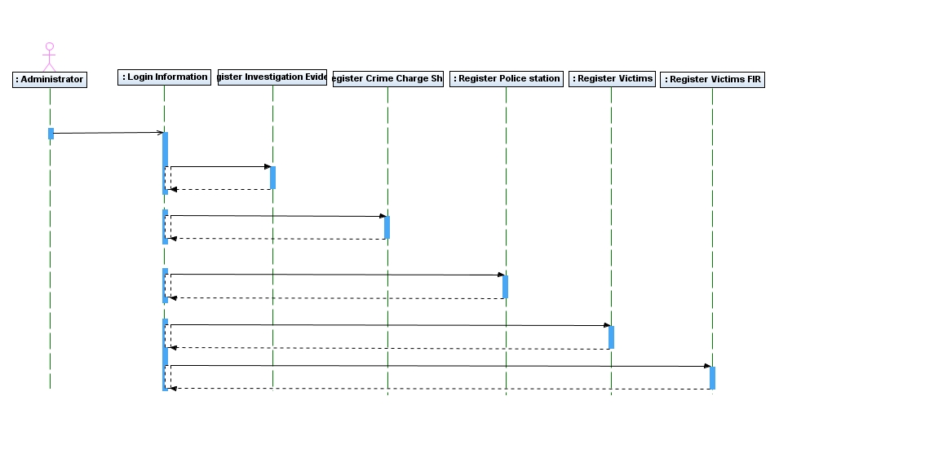

Provide Username, Password

Register Evidence details

Register Crime Charge Sheet

Register Police stations

Register Victims

Register Victims FIR
Investigator:

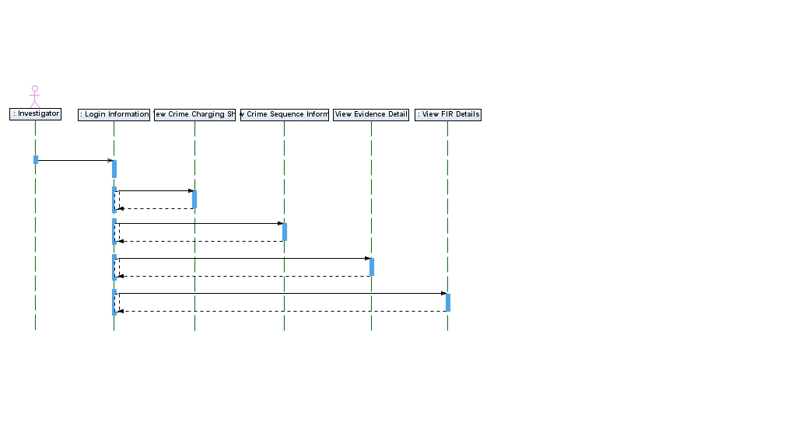

Provide Username, password

View Crime Charging Sheet

View Crime Sequence Information

View Evidence Details
View FIR Details

Writer:
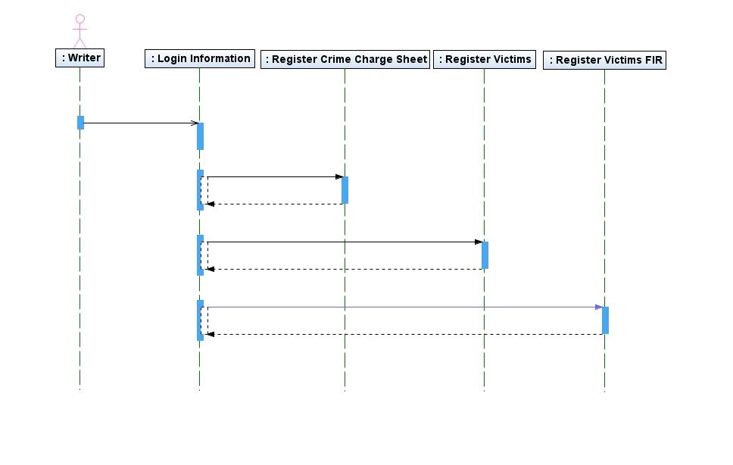

Provide Username, password
Register Crime Charge Sheet
Register Victims
Register Victims FIR

Class Diagram:

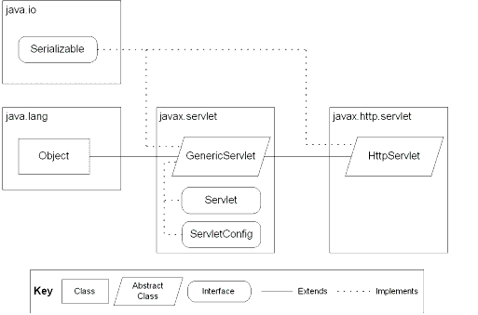
JSP: Implicit Objects

Component Diagram

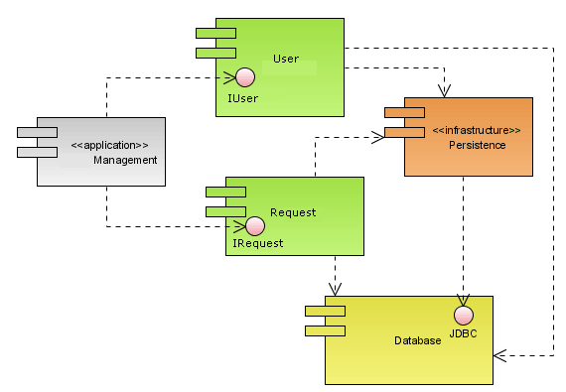

Deployment Diagram
